AI Harness, Taxonomy, and Ontology helps you win AI Use Case, a benchmark story

AI Engineering teams often focus on model selection, prompt engineering, context engineering to solve AI use cases ranging from simple generative problems to level 4 autonomous business operations.
However, the actual intelligence of AI Agent is only partially determined by these (model, prompts etc) and increasingly determined by harness you put around it.
Recently released GPT6 Astra scored 62.7% on ARC-AGI benchmark of 62.7% with regular AI harness and scored 99.9% with better memory harness. This proves this point beyond doubt. In this blog we go through autonomous customer support AI use case and share a benchmark that also observes similar improvement from 62% to 92% using better knowledge base harness (more details later). Increasingly with powerful LLMs as given, the real value is shifting more to harness layer.
What is AI Harness you say? It is things such as AI memory, knowledge taxonomy, planning and observing loops, available skills & tools and finally ontology. While this blog is too short to go into details of each of these, we would look specially at knowledge taxonomy and knowledge retrieval. For details you could read y earlier blog “Your AI Agent Needs a Knowledge Taxonomy — A Reference Implementation of HCAG”. This blog would continue from where last one ended, going from theory and implementation to benchmark scores and insights from that. This would also illustrate the importance of AI Harness in implementing good quality AI use cases.
In the benchmark, we took 58 SME validated questions of different level of difficulty going from simple, medium, complex to hard. The key observation was that identical AI Agents with same knowledge base, same prompts, same model however, with one with stronger AI knowledge retrieval Harness (HCAG) vs one with weaker AI knowledge retrieval Harness (RAG) performed very differently (see diagrams below, full benchmark at github link).

The answers by agents (RAG and HCAG based) were scored from 0 to 3 in accuracy and quality, with 0 being wrong answer, 1 being right answer with key facts missing and 3 being right answer that is comprehensive and accurate.
What was observed that AI Agent with stronger harness (HCAG) held acceptable answers (>=2 out of 3) to 100-94% while RAG deteriorated from 89% to 50% as difficulty of questions increased.
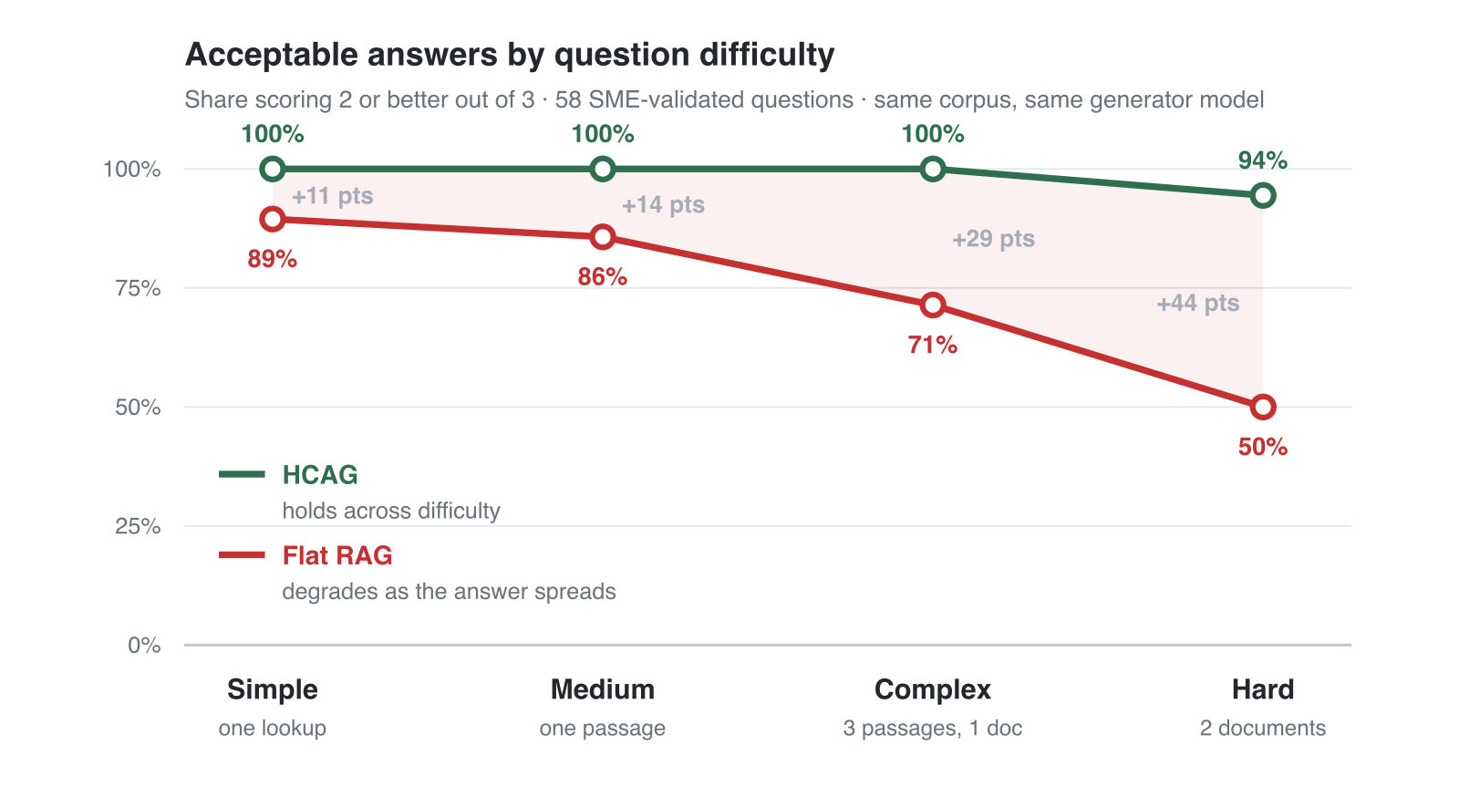
Quality of answers also held by HCAG from 93% to 89% while RAG based identical agent dropped from 84% to 52% as questions increased in difficulty. This was despite RAG using hybrid search and best chunking and embedding strategies.
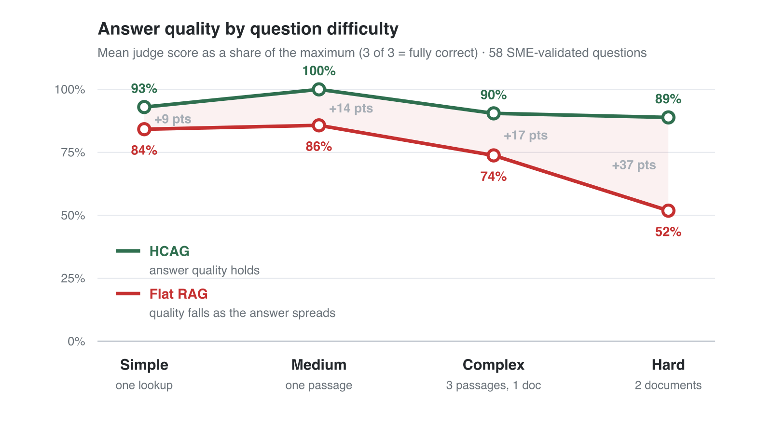
Key take away for AI teams is, pay attention to the harness you use around the agent, not only the LLM, prompts and context engineering. I will cover more of these AI harness in future blogs. For now if you want a reference implementation of this knowledge taxonomy based Hierarchical Context Augmented Generation, head to github link.

